Laying Up Supper at Colne Yacht Club

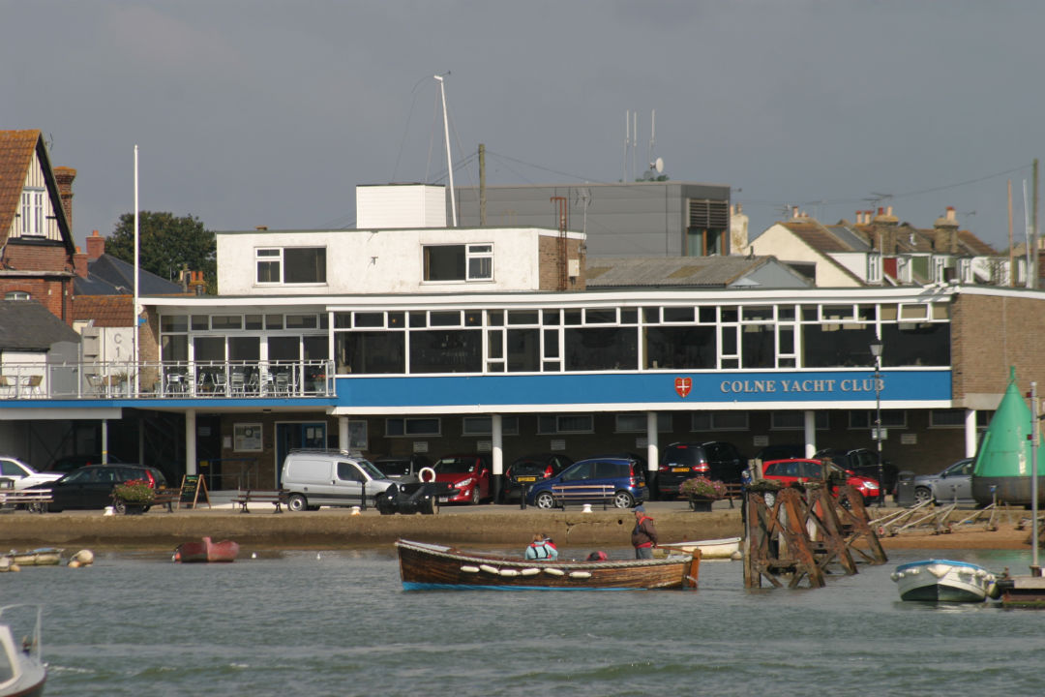
Waterside, Brightlingsea, Colchester CO7 0AX

17th October 2015 19:30 for dinner at 20:00
Our Laying up Supper this year will be at the Colne Yacht Club. This is somewhere we’ve had successful lunches in the past – It is a very scenic location overlooking the busy port of Brightlingsea and we’d like to invite members of local yacht clubs to join us so please pass this on. The menu is excellent and the company at these events always convivial.
THOSE NOT ALREADY MEMBERS OF THE CRUISING ASSOCIATION WHO JOIN THE CA ON THE NIGHT WILL GET THEIR MEALS FREE!!!!
Cruising Association Website | Link to CYC website | Google map

STARTERS
Deep Fried Brie Wedges and Cranberry Sauce
or
Goat’s Cheese Salad, Parma Ham, honey + lime dressing
or
Smoked Salmon Cornets, dill mayo tartlet with lime Dressing

MAINS
Pan-fried Chicken stuffed with mozzarella and sundried
tomatoes with madeira sauce
or
Braised Lamb Shank, cooked in mint and red wine sauce
or
Salmon fillet en croute, with dill cream sauce
or
(V) Shallot and Red onion Tarte Tatin
or
(V) Brie, Roasted Veg and sundried tomato flan

All served with seasonal vegetables

DESSERTS
Chocolate and Baileys Cheesecake
or
Raspberry Pavolva with raspberry coulis
or
Ginger and Golden Syrup Pudding with creamy custard

Followed by Cheese and Biscuits / Coffee

PRICE PER HEAD: £29.95 (VAT included)
Booking form attached.

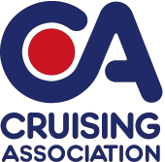 | 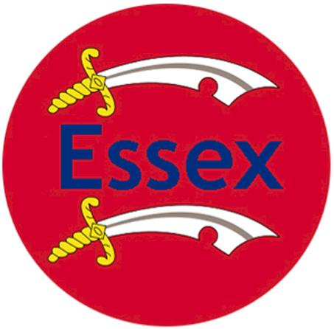  Laying up Supper Booking Form  Saturday 17th October 2015 - 7:30pm For 8pm  Colne Yacht Club  Waterside, Brightlingsea, Colchester CO7 0AX
Please Forward Completed Form preferably by email To: E-mail: mailto:essex@cruising.org.ukTel: 01621 783674
Post: John Blakesley, Section Secretary,
115, Leslie Park, Burnham-on-Crouch, Essex, CM0 8SY

Menu – Please indicate numbers for each option.
After dinner a cheese board, coffee and mints are included in the price.
COURSE | Name |  | Name | Name |  | Name
STARTERS
Deep Fried Brie Wedges and Cranberry Sauce
Or:
Goat’s Cheese Salad, Parma Ham, honey + lime dressing
Or:
Smoked Salmon Cornets, dill mayo tartlet with lime Dressing
MAIN COURSES
Pan-fried Chicken stuffed with mozzarella and sundried tomatoes with madeira sauce
Or:
Braised Lamb Shank, cooked in mint and red wine sauce

Or:
Salmon fillet en croute, with dill cream sauce

Or:
Shallot and Red onion Tarte Tatin ^{V}
Or:
Brie, Roasted Veg and sundried tomato flan ^{V}
DESSERT
Chocolate and Baileys Cheesecake
Or:
Raspberry Pavolva with raspberry coulis

Or:
Ginger and Golden Syrup Pudding with creamy custard

PLEASE BOOK BY FRIDAY 9th October 2015
Please calculate your costs below for the event
Members of CA, Guests and visitors | Dinner @ £29.50 each | Total Cost:£________
Please indicate which one of the following payment options you prefer:
☐I enclose a cheque for £____.____ (cheque payable to: Cruising Association – Essex Section).
☐I prefer using online transfer and will transfer the following amount £____.___
Online transfer the bank details are as follows:Bank: NatWest Sort Code: 60-22-06 Account No. 96421053.
Please also provide the following details:
Name: | Tel:
Address:
E-mail:

