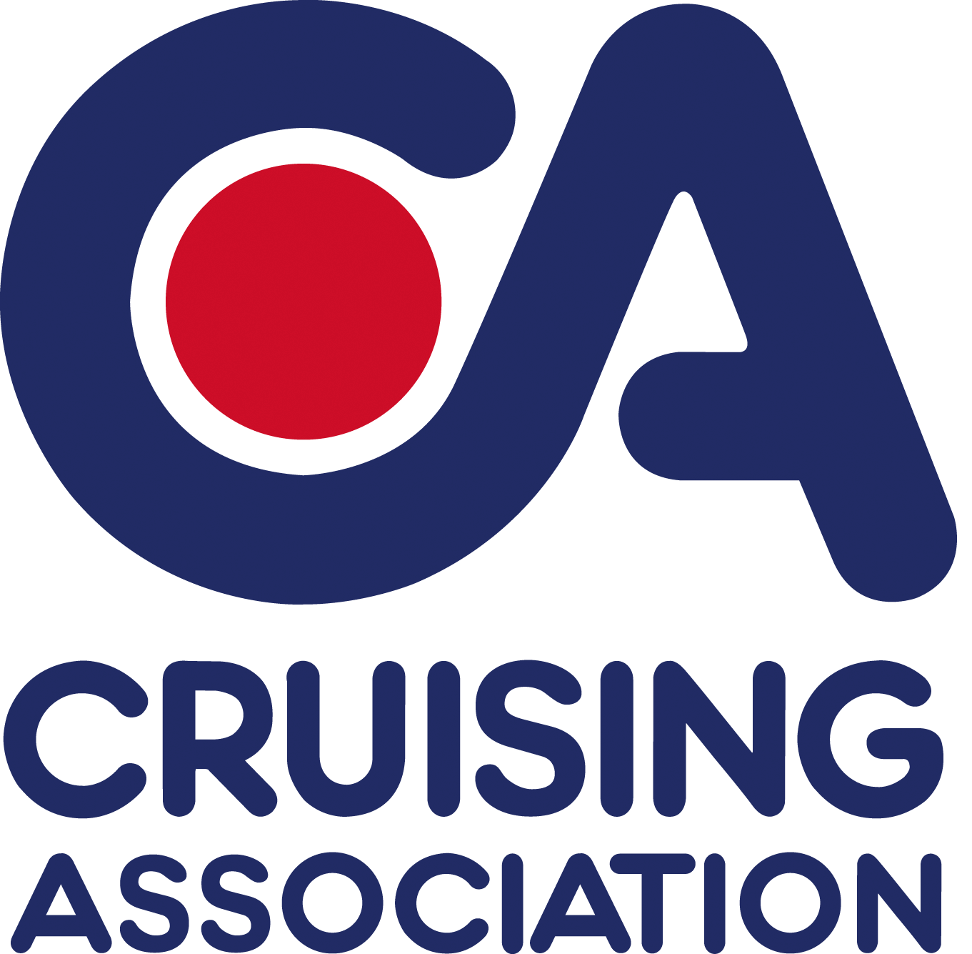

CA House
1 Northey Street
Limehouse Basin
London E14 8BT

Tel: +44 (0)20 7537 2828
Fax: +44 (0)20 7537 2266
Email: office@cruising.org.uk
www.cruising.org.uk

Please reply to Section Secretary:
John blakesley
(E-mail: essex@cruising.org.uk)
Booking for talk to
Treasurer Peter Barnard
(E-mail: peterb123@tiscali.co.uk)
P Barnard
Beaumont
Queen Street
Fyfield
Essex
CM5 0RY
Buffet Dinner & Talk on
7th February 2015 6:30 for 7pm at Blackwater Sailing Club

Our meetings are held at Blackwater Sailing Club, Basin Road, Heybridge Basin, Maldon, CM9 4SD.

Directions: Exit the A12 at the Hatfield Peverel junction. Take B1019 to Heybridge
(approx. 6 miles). Turn left at first roundabout on to B1026; turn right at second roundabout, staying on B1026 towards Goldhanger; after a mile turn right for Heybridge Basin (it is easy to drive past this turning); the Club entrance is 200 yards on the left. See www.multimap.com

February’s talk is not only the last talk this winter but also has a slightly different format – a buffet dinner to encourage sociability. This is an experiment and we would appreciate your comments.

The focus of this month's talks is on preparation for the cruising season and we look forward to hearing some useful and varied contributions to this:

Before the Buffet Dinner

Colin Penn of the Cruising Association Crewing Service
Colin will briefly introduce the CA Crewing Service where skippers can make contact wit potential crews, and crews with skippers. This will give people a chance to discuss the service with him during the dinner.

After the dinner:

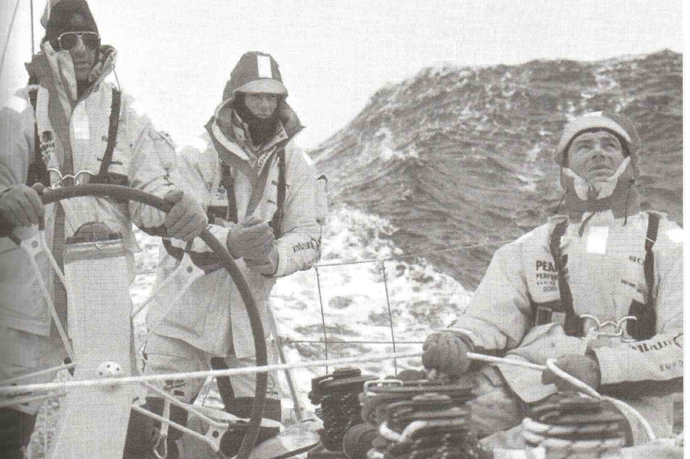
Alan Wilson “A brief intro to Heavy Weather and how to survive it”
Alan, an Essex Sailor, tells us he started sailing when his Dad put him in a dinghy on a reservoir (aged 10) and told him to get on with it. He got to the other side (downwind) in 5 minutes, and then took an hour to get back, by watching other people who knew how to beat.

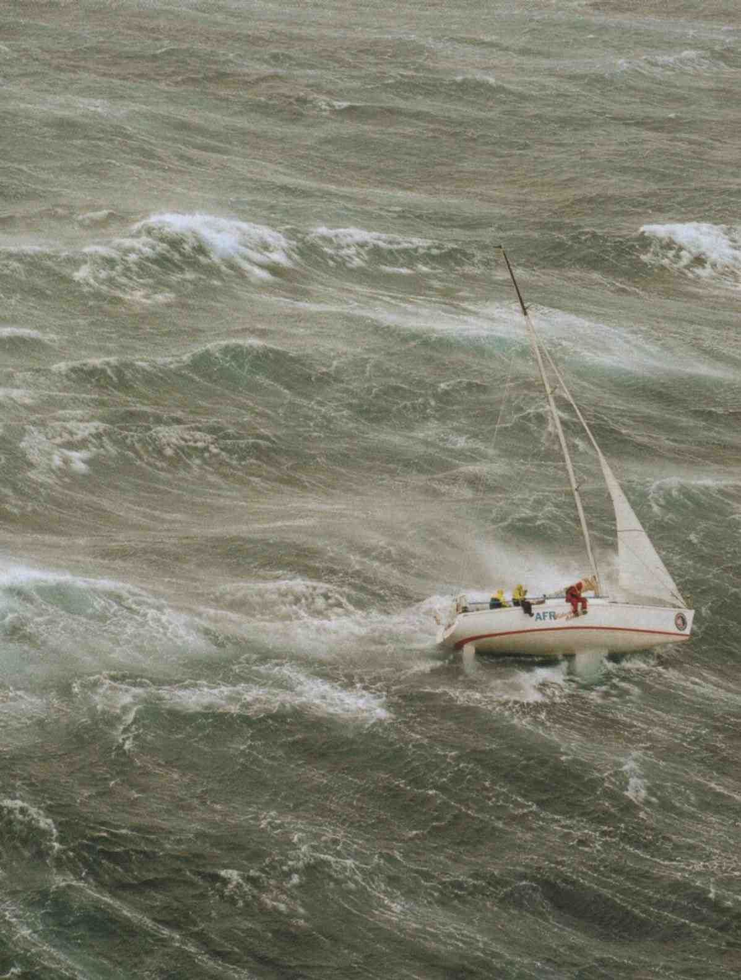
Since then he's sailed around 30,000 miles, mainly single-handed: these are his thoughts on how to avoid heavy weather and, if you’re caught out in it, how to cope. He says his talk aims more at the sort of weather you might encounter in the North Sea than the Southern Ocean.

He considers preparation; what direction to go, whether to run, reach or beat, use of the engine, anchoring, when to use the life raft and how to cope with being rescued.
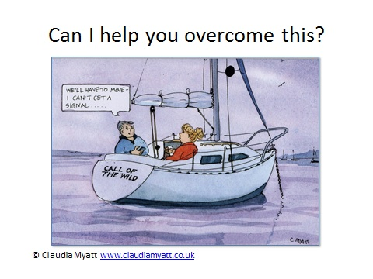

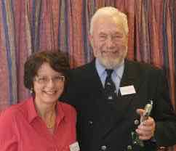
Sue Sutherland ”Staying in Touch Whilst Cruising’
Our own Sue Sutherland, CA Web Editor, promises to provide excellent advice for the upcoming cruising season. Sue and her husband Ron cruise extensively whilst Sue manages to continue her work in IT for the CA so she is well qualified to help us with this topic.

Please use attached booking form:

Best Wishes and good sailing

John Blakesley
Essex Section Joint Secretary
H 01621 783674
M 07866446757
mailto:essex@cruising.org.uk

Booking for talk to
Treasurer Peter Barnard
(E-mail: peterb123@tiscali.co.uk)
P Barnard
Beaumont
Queen Street
Fyfield
Essex

Talk and supper at Blackwater Sailing Club 7th February 2015
Once completed please send or email to our treasurer:
Peter Barnard, Beaumont, Queen Street
Fyfield, Essex
CM5 0RY.
mailto:peterb123@tiscali.co.uk?subject=CA Talk/Dinner Booking Form
Tel: Home. 01277 899233 Mobile. 07836 538074

Please tick your choices and state numbers for each option | Number
Buffet Dinner | …………
Please calculate your costs below for the event
Member(s) of the C.A. or BSC | Numbers for meal and talk@ £13:00 each…… | Numbers for talk only @ £3.00 each…….. | Total Cost:  £________
Non-member(s) of the C.A. or BSC | Numbers for meal and talk@ £15:00 each…… | Numbers for talk only @ £5.00 each…….. | Total Cost:  £________

*I enclose a cheque/Bank transfer for £____________.________
(CHEQUE PAYABLE TO: CRUISING ASSOCIATION – ESSEX SECTION)

For those wishing to use online transfer the bank details are as follows:
Bank: NatWest Sort Code: 60-22-06 Account No. 96421053

*Please indicate preferred option.
NAME(s)….……………………………………………………………………………………………
ADDRESS……………………………………………………………………………………………………………………
……………………………………….....................................................................................
Please include your boat name if you wish………………………………………………
Tel and E-mail:…………………………………………………………………………………………………………..
Guests names…………………………………………………………………………………………………………….

Last booking date Monday 2nd February 2015

