 **ESSEX SECTION** 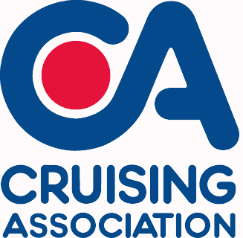

# Booking Form

**Talk and supper at Blackwater Sailing Club 7th November 2015**

**Once completed please send or email to our treasurer:**

**Peter Barnard, Beaumont, Queen Street**

**Fyfield, Essex**

**CM5 0RY.**

[**mailto:peterb123@tiscali.co.uk?subject=CA Talk/Dinner Booking Form**](mailto:peterb123@tiscali.co.uk?subject=CA%20Talk/Dinner%20Booking%20Form)

**Tel: Home. 01277 899233 Mobile.** **07836 538074**

Menu – Please indicate names for each option.

|  |  |  |  |  |  |  |
| --- | --- | --- | --- | --- | --- | --- |
| **COURSE** | **Name** | | **Name** | **Name** | **Name** | |
| Main Course | | | | | | |
| Aromatic Lamb With Dates |  |  | |  | |  |
| Or: | | | | | | |
| Mustard And Sage Chicken |  |  | |  | |  |
| Or: | | | | | | |
| Salmon Kebabs With Chilli And Lime Dip |  |  | |  | |  |
| Or: | | | | | | |
| Squash And Sage Pithivierv |  |  | |  | |  |
| **Dessert** | | | | | | |
| Squidgy Chocolate And Pear Pudding |  |  | |  | |  |
| Or: | | | | | | |
| Maple And Pecan Cheesecake |  |  | |  | |  |

Please calculate your costs below for the event

|  |  |  |  |
| --- | --- | --- | --- |
| Member(s) of the C.A. or BSC | Numbers for meal and talk@ £12.50 each…… | Numbers for talk only @ £3.00 each…….. | Total Cost:  £________ |
| Non-member(s) of the C.A. or BSC | Numbers for meal and talk@ £14.50 each…… | Numbers for talk only @ £5.00 each…….. | Total Cost:  £________ |

Please indicate which one of the following payment options you prefer:

☐I enclose a cheque for £____.____ (cheque payable to: Cruising Association – Essex Section).

☐I prefer using online transfer and will transfer the following amount £____.___

Online transfer the bank details are as follows:Bank: NatWest Sort Code: 60-22-06 Account No. 96421053.

Please also provide the following details:

|  |  |
| --- | --- |
| Name: | Tel: |
| Address: | |
| E-mail: | |

**Last booking date Monday 2nd November 2015**