Talk & Supper at Blackwater Sailing Club: 8th March 2014
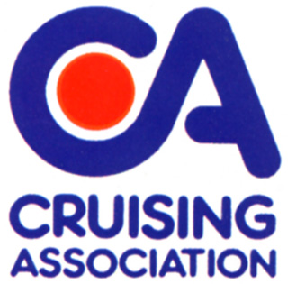
Please post to: Peter Barnard, Beaumont, Queen St., Fyfield, Essex. CM5 0RY
or email: peterb123@tiscali.co.uk Tel: Home. 01277 899233
This form is in 'Word' format so you can add your details

Please tick your choices and state name against each option | Number(s)
Main Courses  Spicy sticky chicken .....................................................................................................  Goulash with Meatballs ................................................................................................  Pork Wellington .............................................................................................................  Stuffed Portobello Mushrooms .................................................................................  (All to be served with roast potatoes, roasted vegetables and seasonal vegetables) | .....................  .....................  .....................  .....................
Desserts  Crème Caramel ...............................................................................................................  Lemon Tart .....................................................................................................................  Fruit Crumble ................................................................................................................. | .....................  .....................  .....................

Please calculate your costs below for the event

Member(s)  of the C.A. or B.S.C. | Numbers for meal and talk @ £12.50 each ................ | Numbers for talk only  @ £3.00 each ................ | Total Cost:  £__________
Non-member(s)  of the C.A. or BSC | Numbers for meal and talk @ £14.50 each ................ | Numbers for talk only  @ £5.00 each ................ | Total Cost:  £__________

*I enclose a cheque – OR - will make a Bank transfer for £ _______.________
(cheque payable to: Cruising Association – Essex Section)
*Please indicate preferred option.

For those wishing to use online transfer the bank details are as follows:
Bank: NatWest Sort Code: 60-22-06 Account No. 96421053

NAME: .................................................................................................................

ADDRESS: ..........................................................................................................

.............................................................................................................................................

Tel and email: .....................................................................................................

Very last booking date: Tuesday 4th March 2014

